Class 2: Defining Literacies


Wellness check in: “This Is Me: Today’s Edition”

“Choose a book or magazine cover, landing page, etc (real or imagined) that reflects how you're feeling right now—emotionally, mentally, or physically. You can share just the title, describe the vibe or design, or explain why it captures your current mood or mindset.”
Examples:
Cloudy With a Chance of Meatballs – “Things feel a little chaotic but kind of funny.”


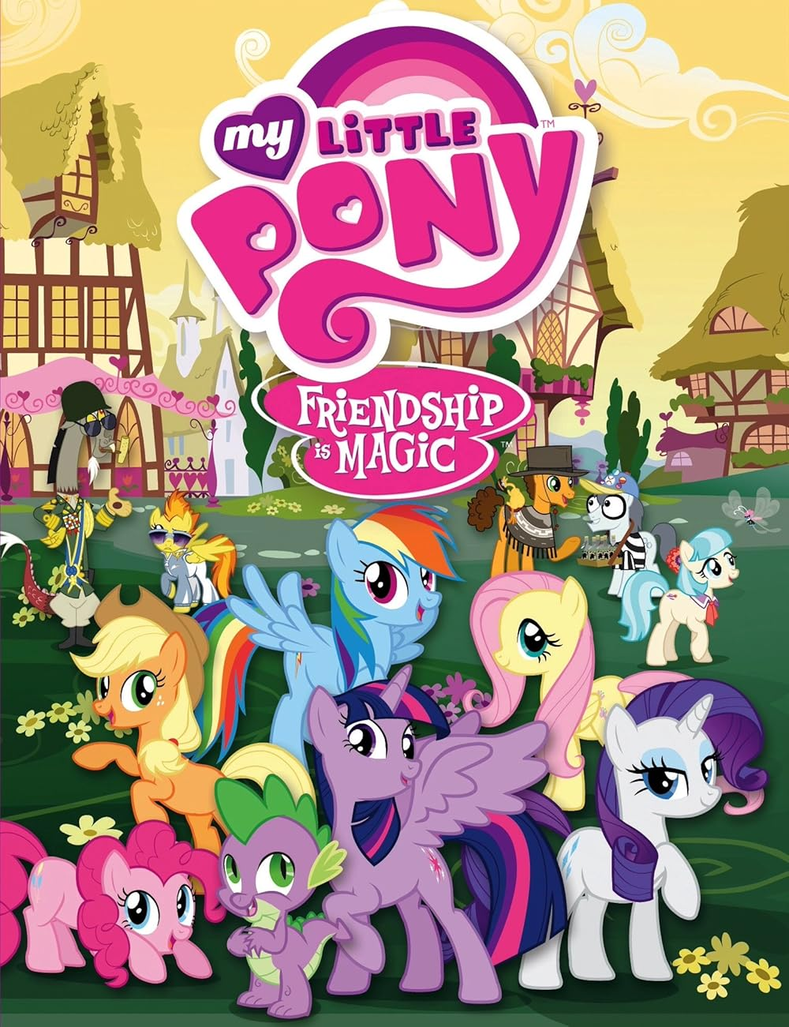My Little Pony because I am surrounded by my friends :) I reached out to a friend in need and we shared a hug as a result of me opening up communication. I also reached out to an old friend whose birthday is today, and caught up with him, which left me feeling joyful and excited for the future.
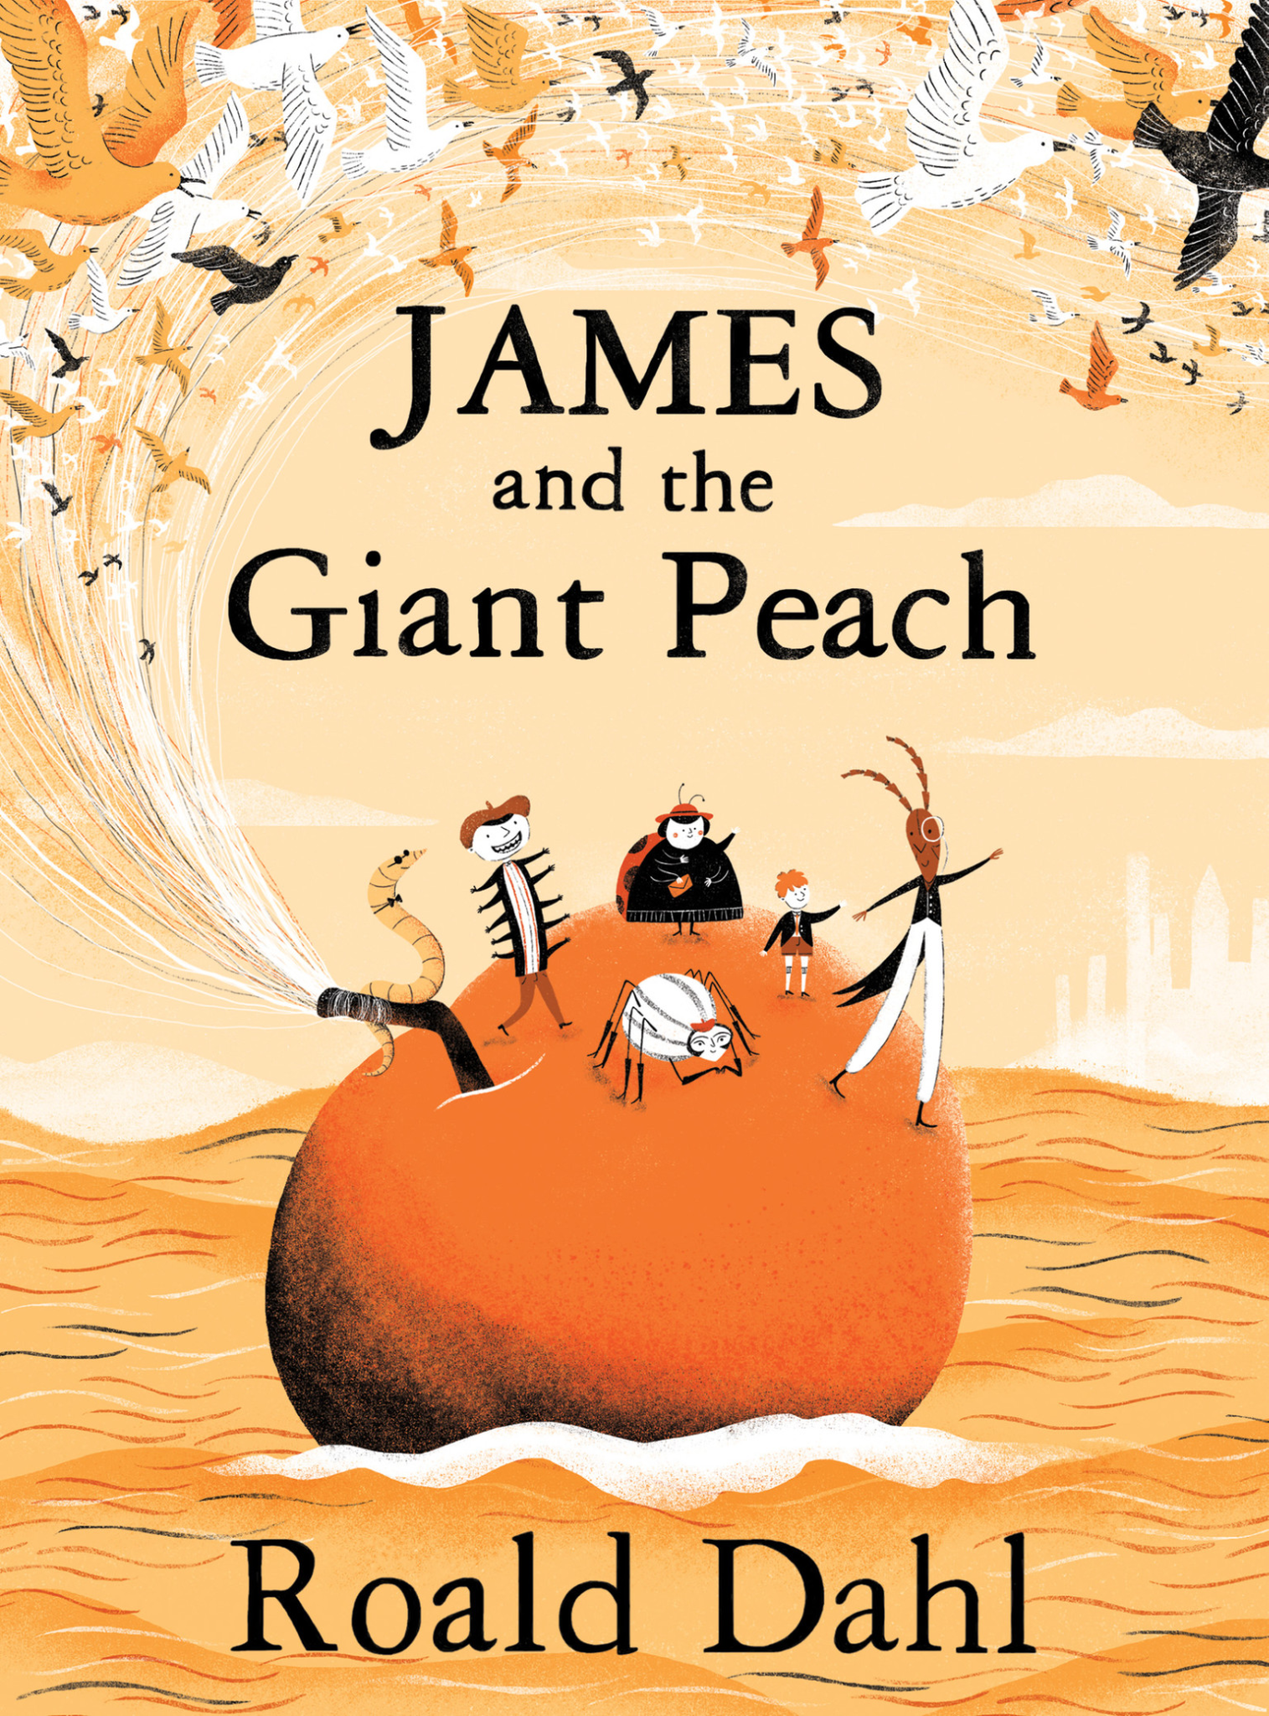 James and the Giant Peach because I feel like I'm on an adventure.
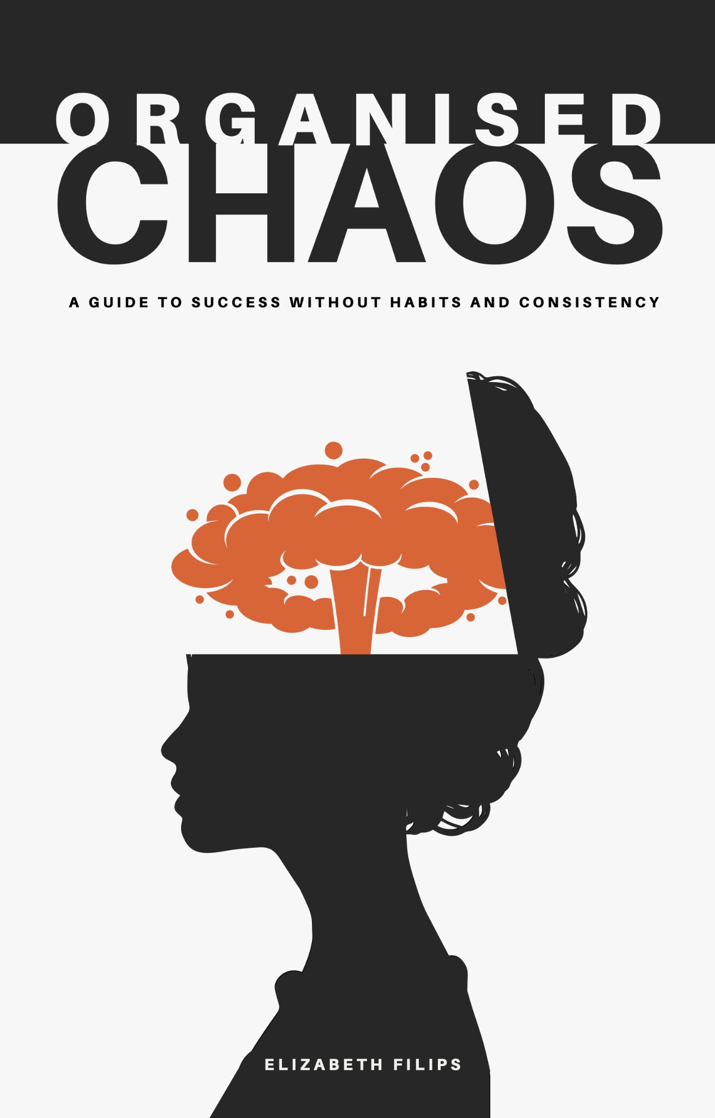Organized Chaos: Everything feels a little hectic at the moment with juggling schoolwork, personal responsibilities, and work but somehow I'm still organized.
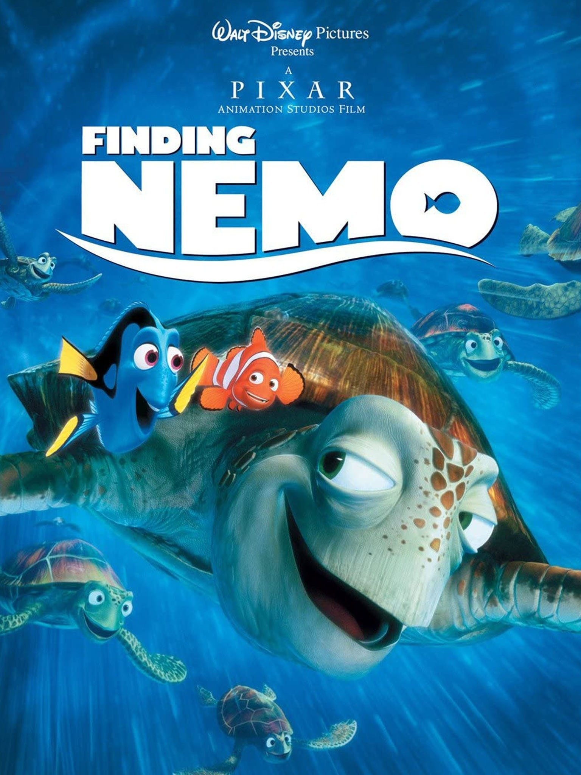Finding Nemo–I feel like I am starting to find the groove in my life and everything is falling into place (even though the future is a bit shaky and feels like a long journey ahead of me). Starting a new chapter, I hope to form new connections and persevere :))
.
This is a bit silly but I’m teaching “organic chemistry” to my students right now and I feel a lot like how I did before I started my college organic chemistry classes– no idea what is going on and I’m already confused. This frog is also kind of relatable
I’ve never actually seen this movie but I feel like the title sums up how I’m feeling–pretty busy and all over the place. I just moved and along with unpacking I’ve been working full time and just starting classes again after a year off of school.
 I am very exhausted this week, a lot of new things are coming. I am also in charge of a butterfly exhibit and I’ve seen a lot of butterflies emerge from their chrysalids. The news are also very demotivating.
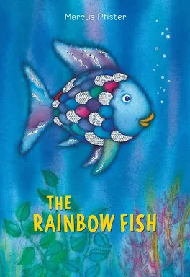Rainbow Fish because I had a lot of Goldfish before class and am feeling cheerful.

Revisit Classroom Guidelines (15 min.)
Classroom Guidelines
In break out rooms Synthesize your questions to 1-2MAX sentences
We will collectively agree on them after
- Remember the human.- Remember that everyone has been through their own challenges. Treat your classmates’ critiques as good faith attempts to engage with you. Be culturally competent. Engage in conscious cultural relativism. Assume good intentions when interacting with others. Take time to consider how multifaceted we are. Consider sensitivities and remember that emotion or passion is not the same as weakness or irrationality.
Remember that everyone has been through their own challenges, and that emotion/passion is not the same as weakness/irrationality. Be considerate of others and understand that they are trying to engage with you and your culture, so you should respectfully attempt to do the same. *Staying committed to shared understanding
- Adhere to the same standards of behavior online that you follow in real life.- Engage online respectfully. Do not use the online realm as a shelter for disrespectful behavior. Treat others with the kindness you would treat your friends. Remember the virtual world still reflects the real one. Act civilly online. Engage constructively in discussions.
Engage constructively with others online as you would with people in person; with respect, kindness, and empathy.
- Know where you are in cyberspace.- Familiarize yourself with the technology being utilized. Hop onto Zoom a little earlier to ensure that you can make it into the classroom. Be aware of what you share in the cyberspace. Be conscientious of your own digital footprint. Be considerate about your use of AI and related technology. Be mindful of the digital tools you use.
Use technology meaningfully and responsibly, ensuring that you are aware of the strengths and limitations of your digital resources.
- Respect other people's time and bandwidth.- Communicate Challenges. Be fully engaged when someone else is contributing. Be considerate of other people’s time to share their thoughts; don’t be a discussion hog! Step up, step back. If you have not spoken yet, speak up, share your opinion, even if it is brief. If you are speaking a lot, step back, let someone else take the stage. Use the same receptive social skills as you would in person. Be concise when possible. If you notice that someone else wants to speak, step back
Value the other person's contributions online by considering time and be as respectful as you would in real life interactions.
- Make yourself look good online- ensure your face is in full frame and that you do not have any distracting backgrounds or visual effects enabled . - Be present to the fullest extent possible, as though you were in an in-person setting – that doesn’t mean you have to look perfect at all times. Be prepared to be fully present. Be comfortable in what you are wearing. Show yourself as if you were in an in-person class. Practice active listening when appropriate.
Ensure your face is in full frame and that you do not have any distracting backgrounds or visual effects enabled. Be present to the fullest extent possible, as though you were in an in-person setting.
- Share expert knowledge. Make contributions with strong foundations. Participate with critical thinking. Know that it’s okay if you are unfamiliar with a topic; that’s the point of learning. Acknowledge that intelligence is relative. Recognize our shared goal of learning and working toward shared conclusions when possible.
Make contributions with informed foundations from depth of practice and research and participate with critical thinking. It’s okay to be unfamiliar with a topic; that’s the point of learning, continue leverage cultural resources in the community
- Help keep flame wars under control. Agree to disagree when necessary, and advocate for open and respectful communication. Communicate with others with an open mind and do not be offended if someone has a different viewpoint than you. Practice listening deeply. Recognize certain scenarios that should not be engaged with. Accept that disagreements and discomfort will occur, but remember that we are all first and foremost in community together as learners.
Accept that disagreements and discomfort will occur, and advocate for open and respectful communication. Experiencing discomfort and conflict helps us to grow as learners.
- Respect other people's privacy. Do not share personal information that others confided in during the class. Take the lesson away from the moment, not the story. Engage conscientiously. Think about how you value your own privacy and apply that lens towards other people online. Engage with others at their level, being open to what they are willing to offer while maintaining boundaries.
Respect other people's privacy and do not share personal information that others shared during the class. Focus on the lesson, not the story.
- Don't abuse your power. – Be aware of how much space you take up in a room and work towards lifting others up rather than shutting them down. Be cognizant of the power you carry and how you can use that power for good. Be conscious of your privileges and how they can affect others. Recognize that your experiences will be different from everyone else's. Everyone carries some level of power and privilege, be conscious of how you wield it. Respect everyone and remember we are all diversely oppressed by broader power dynamics in some way. Listen first, especially when in a position of leadership.
Be mindful of your own privilege and power do not weaponize it but use it to uplift others by listening, respecting differences of opinion (as they TOO can be right) and make space for everyone to contribute.

- Be forgiving of other people's mistakes. We are all here to learn, and brave spaces are there to challenge our viewpoints, and those of others. Making mistakes is a part of being human; be aware of these mistakes and learn from them. Be gentle with yourself and others; these are opportunities for growth. Do not blame just the person, try to step in their shoes or look at the bigger picture. Remember that we bring our whole selves into the classroom, and education is a holistic, active process.
Approach the mistakes, yours and your peers, with empathy and openness; to be human is to make mistakes. Recognize in these moments opportunities for growth, deeper understanding of ourselves, our community and the topics we are tackling.

Class 2 Objectives:

- Collectively Set Norms - revisit classroom guidelines
- Expand Multiliteracies Awareness: We will broaden our understanding of literacy to include diverse, multimodal forms of expression, such as visual, digital, and performative literacies, through activities like pantomime. This will help us recognize the various ways literacy can manifest beyond traditional text-based forms.

- Reflect on Literacy as a Tool for Empowerment: Drawing on the theories of multiliteracies and Gholdy Muhammad's notion of literacy as a tool for liberation and power, we will reflect on and broaden our personal definitions of literacy. This reflection will include considering the potential of literacy to foster liberation, empowerment, and social change within their communities.

Activating our Understanding (8 min)
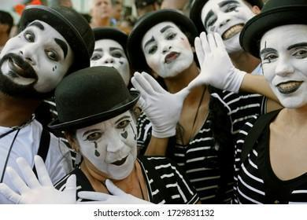
- Expressive Interpretation: Historically, pantomime, originating from ancient Greek and Roman theater. It was a powerful way to communicate without words. However, it has also been misused in ways that perpetuate harmful stereotypes.

- To reclaim this tradition, in the breakout rooms spend 1-2 minutes considering something that brings you joy and choose non-verbal method to communicate it that honors your cultural identity, such as gestures, visual art, instrumental music, or any other form of silent expression. Take turns with your partner but do not tell your speaking partner with words what you are trying to say.

- Return to whole group for share out: We will share in the mainroom how we interpreted our partners pantomime. We will discuss what you learned about your source of joy and reflect on the cultural and historical significance of the mode of expression you chose. Consider how non-verbal communication and its cultural variations inform our understanding of connection and expression in our communities today.

Activity 2: Extending the Discussion Board Conversation: Core Questions About Literacy ( 15 min Breakout + 5-7 Main room)
This week’s readings ask us to reconsider what counts as literacy, who gets to define it, and how we as educators can support students’ full humanity and agency as readers. The following quotes and questions, courtesy of Group A discussants and some light curation, are designed to help us get to the heart of those ideas especially as we think about joy, criticality, identity, and power in literacy learning.

Directions : In your breakout groups select 2–3 of the following questions to focus your group conversation. Tell us which questions you focused on and take notes in the provided box below. Elect a spokesperson to speak for the group in the main room :
- What counts as reading?
In your eyes (and in your classroom), what qualifies as valid forms of reading: physical books, audiobooks, comics, video games, YouTube subtitles? What doesn’t count, and why and who gets to decide?
students of color, and what practical steps can we take to prioritize them?
- Can “snackable” or “situated” content be meaningful?
How might we reframe students’ consumption of digital content as a form of literacy and what does it take to help them engage with it more critically?
- How do we reflect students back to themselves?
Bishop talks about “lighting conditions” making a window a mirror. What kinds of choices can educators make (in texts, activities, or discussion) to make this transformation possible?
- How do we elevate the student voice while holding onto facts?
In classrooms where many students share targeted identities (e.g., Black and Latinx youth), how do we support both emotional truth and critical thinking? How do we hold space for disagreement within the community?

- Souto-Manning & Yoon (2018): “Young children are exposed to language in various contexts before entering school – homes, communities, peers, and the environment. They start reading their environment and authoring themselves in the world.” How can we incorporate more of these books into the school curriculum?
- Mackery (2020): “Access to reading material is not a politically neutral issue. The publishing industry in English-speaking countries is still very white, both in terms of personnel and product. “We Need Diverse Books” is a campaign that aims to broaden the range and appeal of what is made available to young people; one point that seems very clear is that readers cannot acquire what does not exist.” They need the books as windows onto reality, not just on imaginary worlds" (Bishop, R. pp. 1)How can we, as teachers, balance meeting required academic standards while also incorporating everything we know about literacy learning.

- A question to ponder throughout the semester but … how could we answer this knowing what we know right now: How can the CHRL framework provide more meaningful and lasting change in the classroom compared to frameworks already out there, like culturally responsive pedagogy?
- Souto-Manning & Yoon (2018) establishes three ways educators can transform unjust sociocultural realities: embodied literacy, racial literacy, and critical literacy (76). They give really practical examples of each of these literacies in action but do not discuss their intersectionality. Is there a way to incorporate all three of these literacies at the same time, or if educators should prioritize a specific literacy depending on student demographics and/or daily course content?

Group 1 Names: Moss, Anvitha, Emma
Question: #8
With the right text choice, we feel that Reader’s Theatre can be an embodied exercise that is culturally and racially relevant to the students’ backgrounds, and open up a critical discussion. This can be difficult in schools where there is more strict curriculum, or in schools where the students have not been taught to value their own cultural capital.

Question #2:
The NYT games, Connections, Wordle, those all encompass topics of the world and connecting them in different ways. Who reads what article – talking about the importance of choosing and enjoying what you’re reading is important, gets you motivated in what you’re doing. Seeing fun readings as also rich in literacy, even if they wouldn’t traditionally be considered “studious” or “complex”. Games and crafts can be discounted as trivial, but they perpetuate culture and use the imagination, they are a meaningful way to process information. They can be collaborative, in ways traditional reading isn’t. The collaboration can target social emotional goals, but everyone has to be engaged, if someone is not engaged, then they don’t get to participate in and share in the learning.

Question #
Group 2 Names: Alyssa, Piter, Christina
Question
#4: Having open-communication can help elevate others’ voices, bridging the gap in a disagreement. Make content age-appropriate and inform parents the importance of having these conversations. Talking about a population or topic before the negative incident has occurred; they are people first before they are victims.

#1: All forms of reading are valid; some people need visuals or audio to help understand written materials. We should not be putting students down about what they are reading, especially based on the resources they have available to them; instead we need to encourage them. Unfortunately, it’s the educators that usually get to decide what counts, but the district and state requirements.

#3: Taking your student demographic into consideration and taking that into account for your curriculum. Even students that are not in the classroom should be represented so students do not develop stereotypes about different groups. Ask the students what they are interested in and what they want to read. Readers need various ways to interact with reading materials, such as big-text print or audio. Meaningfully incorporate literacy into the curriculum; the educator should have a read through of the book first to make sure that the book tells the story respectfully. Storytelling shouldn’t only be through novels but also culturally sensitive methods, like oral storytelling.
Group 3 Names - Chase , Sarafina, Zoe
Question
#1,Anything that requires text comprehension counts as reading. From movies/media subtitles, game stories, etc. - Just important to couple with media literacy. We discussed that audio books might not count as reading because it doesn’t require the same cognitive processes. However, when societal norms and standardization end up deciding what counts as reading, it restricts thinking outside the box. For example, for someone whose only possible form of literacy consumption is from audio books, that has to count as reading.
#2, Both snackable and situated content is meaningful. Again, when kids are engaging with any sort of reading it should still count as literacy and not diminish their different forms of engagement with reading. Educators should adapt to the different literacy expressions and take advantage of their interest in digital forms of literacy. “...pleasure correlates with reading achievement. (Cullinon, 2000)”

#5- lobbying

10 min. Break

Theory: Slide Deck (20 min)

may 21 class 2.mp4

Names : | At first, we thought…. | Now we think….
Chase Foresti | Maybe some things are objective. | Nothing is objective!

Looking Ahead:

Readings Class 3: Towards the Pursuit of Joy
Unearthing Joy: A Guide to Culturally and Historically Responsive Curriculum Chapter 2
Activating Joy Through Culturally and
Historically Responsive Read-Alouds
Choose one :
Unfolding joy in young children’s literacy practices in a Finnish early years classroom
Activating Joy and Hope in Critical Literacies Instruction: Responding Pedagogically to
Youth Skepticism in a YPAR Project

Asynchronous work: Activity 3
Part 1: Building on the Basics
Building our collective capacities and reflecting on our readings, what is missing from the new basics?

How can we expand new basics to incorporate the readings from this module?

Include 1-2 Culturally Historically Responsive Foundations that should be considered basics.
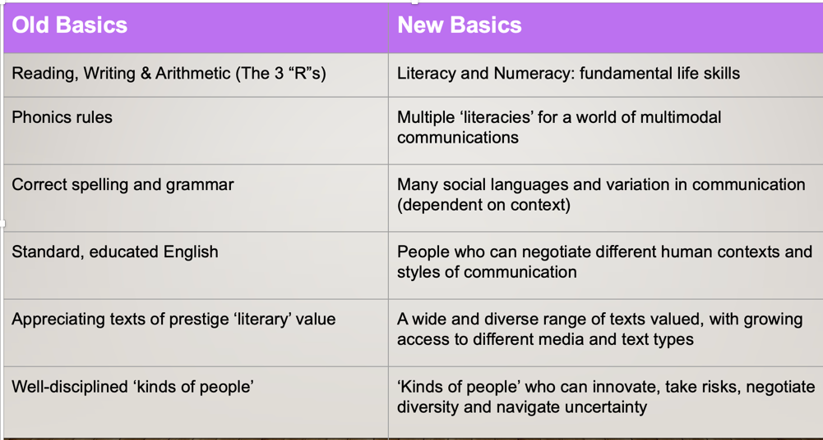
Name | Culturally Historical Responsive Foundations
Christina Ramirez Ward | I think something that can be expanded upon has to do with “people who can negotiate different human contexts and styles of communication.” What comes to mind for me is the idea of code-switching. In certain contexts, society celebrates the capabilities of a person being able to code-switch, meaning the practice of adjusting your language or dialect to fit into a specific social setting or culture. In the education context, however, the ability to code-switch would not help a student with their academics and would be penalized if they do not use the appropriate English standard of speech. To fix this rule, it should clearly indicate that code-switching, and other forms of language typically not seen in education, will be embraced and empowered within students.
Anvitha Shoroff | Something I believe is missing is the development of advocacy skills for oneself and for others in the community. The new basics seem a bit “neutral” in that there isn’t room for one’s own voice and character. Learners should be able to use literacy tools to feel empowered and develop more of a critical consciousness, while also navigating multiple contexts and styles of communication as the new basics emphasize.
Sarafina Hilaire | The New Basics are certainly an improvement from the Old, however I think, based on my understanding of our readings, that there is room for elevation. Literacy carries with it a weight of responsibility that must be actualized, put into action. The New Basics seem to approach but stop short of making that leap into “doing” and thats where I believe modifications should be made in the name of criticality. If liberation is the goal, then the New Basics, while they do allude to more inclusion, they can still become more actionable to address the challenges of how we improve ourselves and society.
Emma Randazzese | One thing that I think is missing from the new basics is an understanding of cultures different from one’s own. I think it should be considered a basic to demonstrate the ability to communicate and collaborate effectively across cultural differences.
Alyssa Mandala | I feel like the new basics do not utilize the power of human connection and interaction as much as they could. For example, the new basic “a wide and diverse range of texts valued, with growing access to different media and text types,” is extremely important in making empathetic and well-rounded individuals. To make this new basic more effective, it could be updated to emphasize the importance of letting students present and discuss their personal cultures and identities with other students, and how text is not the only facet of knowledge when it comes to teaching diversity. So, incorporating “identity” from CHRF more thoroughly could make this basic much more effective and personal to individual growth. I think “joy” is also really important to utilize when it comes to this basic, as students should not only come to understand diverse groups of people, but enjoy the process of learning and interacting with other groups of people.
Chase Foresti | I feel as though the New Basics are missing some meaningful context. Though trying to harbor groundbreaking inclusivity, the broadness in approach does not seem to deliver such a powerful punch to traditional norms. For example, when using words like “different”, or "dependent on context”, a certain correlation or example to a new idea or framework such as CRT could be included. Indeed, context matters for everything, but the way this is phrased makes the new basics themselves seem unsure/vaguely aware as to what possible contexts could arise within the new model their language is pushing.
Zoe Cabrea | I think that it is missing the cultural aspect of literacy. It does mention the differences between social languages, but I feel like it could make a clearer statement about encouraging cultural diversity in language use/literacy. This would fall into the Identity part of the CHRF. The “context dependent” addition does need more clarification. Is the variation of language use only allowed in certain contexts? Or is it that the variation happens depending on the context?  Additionally, in the “kinds of people” I would also add something more joyful, such as creativity. We humans are the ones who create language and communication, so why not encourage creativity to transform and evolve literacy?
Moss Limpert | I think its funny that Phonics rules is in old basics instead of new basics – especially given the Science of Reading approach to literacy. I feel like the new basics option placed in opposition to it should just be a separate row on the chart. I feel strongly that digital literacy should be a new basic, both for teachers and for students. There are a lot of ways that big tech and edu tech unhelpfully obfuscate how technology works for the sake of convenience and ease of use that ends up taking understanding of technology away and removing agency and access to key functionality. An example of that would be how Chromebooks force you to use google suite products, and prevent you from using open source alternatives.
Piter Garcia | One thing still missing from the New Basics is literacy as critical participation in digital and multimodal spaces. They move beyond print-only views, yet they should name more directly the literacies students already bring from their homes, cultures, languages, and technologies. In my Pine Brook IGNITE placement, I have watched elementary students debug block code, navigate Google Classroom and digital interfaces, build in Minecraft, use AI as a learning partner, and give classmates “glows and grows.” These are not side skills; they are reading, composing, collaborating, and participating. The culturally and historically responsive foundation I would add is criticality. Students need practices that help them question power, access, representation, and whose voices are centered or erased—especially in computer science, where algorithms, AI tools, and school devices can appear neutral while shaping privacy, authorship, and belonging. Bishop’s mirrors, windows, and sliding glass doors remind me that students need texts and practices that reflect them, help them understand others, and let them enter new worlds without leaving themselves behind. Mackey’s framing—who reads what, in what formats, and why—pushes me to see literacy as socially situated and purpose-driven, not just a bundle of school skills. A fuller New Basics would treat students as multimodal meaning-makers who read, write, speak, listen, code, design, critique, and create across contexts.
Zach McKay | “Multiple literacies for a world of multimodal communications” is a strong basic, but it misses the importance of navigation between modes of communication. Outside of the classroom, there are many contexts in which students will have to switch between modes of communication or avoid certain modes. To justify the importance of all these modes of communication to students we should emphasize Muhammed’s “four-layer equity framework” of identity, skill development, intellectual development, and criticality.
Part 2: New Learners & New Teachers
Building our collective capacities and reflecting on our readings, what is missing from the new teachers' definitions?

How can we expand how we define “New Teachers” to incorporate the readings from this module and better meet “New Learners" needs..

Include 1-2 Culturally Historically Responsive teaching and approaches that should be part of a “New Teachers” practice.
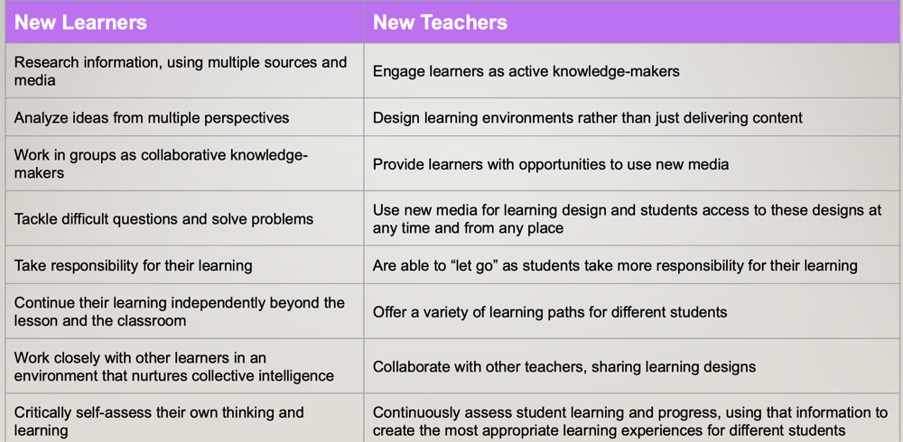
Name | Culturally Historical Responsive Foundations
Christina Ramirez Ward | One rule that I am struggling with is “collaborate with other teachers, sharing learning designs.” I think on paper, this sounds nice on paper but from hearing personal accounts and engaging with some of the other literature, this is not always the case. Especially when it comes to Special Ed and General Ed teachers working together. Special Ed teachers have typically felt underappreciated by the General Ed teachers and feel they do not have a say in any of the lessons unless involves the children with accommodations directly. And if students in the classroom are not seeing effective collaboration among the teachers, then how can they follow suit and work collaboratively with their peers? To top it off, collaboration in the learning designs should go further than simply between teachers, but should also entail the students and general community. If we, as educators, want our students to become well-rounded individuals, then we need to hear multiple perspectives from the community on how we can accomplish this goal.
Anvitha Shoroff | Instead of new teachers “designing learning environments” for learners, teachers should involve learners in the process of designing a learning environment. Going back to the idea of empowerment and identity, a new teacher should inspire learners to trust their own knowledge and value the unique characteristics they bring to learning spaces. The idea of “taking responsibility for learning” is unclear and seems aligned to a defined, unilateral curriculum. It doesn’t leave much room for collaboration and critical thinking. Instead, I think new teachers should bring out learners’ own motivation to apply their knowledge meaningfully. Teachers can ensure that learning becomes memorable and purposeful to students, rather than being something they have to “take responsibility for” as an “educated” citizen.
Alyssa Mandala | I think that the new teachers’ definitions are very surface-level and flat; they feel like a checklist of great qualities teachers should have but don’t necessarily describe how to utilize them. The last new teachers definition stands out to me, because “assessing” can be seen as an oppressive structure for a lot of reasons. I think it is important to interact with and understand students rather than solely assessing them, as this can help educators not only form connections with their students, but recognize that their teaching habits may be what is leading to a student’s struggle, rather than the student’s own abilities. I think CHRF’s “skills” and “intellect” would be useful additions to this definition, as “creating the most appropriate learning experiences” could easily be utilizing a student's interest and ensuring that, from an educator’s standpoint, it is interactive, culturally relevant to the content at hand, and help that student prosper/grow.
Chase Foresti | To add on collaborating with other teachers/sharing learning designs- Collaborate beyond just one group of practitioners who are not defined strictly as teachers. For example, the community (e.g., parents/policymakers)- not just the local, but the global, as we are all global citizens in the multimodal world. Collective intelligence is nearly inescapably international now. I feel as though the global context could be emphasized more for all of these “New Teacher” needs.
Emma Randazzese | Adding on to “offer a variety of learning pathways for different students,” I think it’s important to provide a choice when it comes to learning. Examples of this could be offering multiple books that teach the same theme, options of format for a final presentation (powerpoint, video, paper, etc.), or allowing students to choose the topic for a research paper. Even if the choice is structured or only between two options, the act of choosing engages learners and provides a bit of motivation and excitement to learn.
Sarafina Hilaire | To better instruct New Learners necessitates that New teachers cultivate their own genius. It is an improvement that classrooms and the curriculum have become more inclusive, but that also creates a higher demand for responsiveness on the part of the teacher. New Teachers can and should continue to meet that standard by continuously empowering themselves so that they can be better equipped to assist students in actualizing their own brillance.
Zoe Cabrera | I think that the New Teachers' definition is lacking some more assertive criticality. The teaching methods should encourage more agency and an active role from students to break through the normative standards of literacy that do not take into account oppression, inclusion, or cultural diversity for the most part. I think that should be something New Teachers should constantly stimulate in learners.
Moss Limpert | I see a venn diagram here, with no center overlap. New teachers are also new learners, and in being new learners, new learners should also be new teachers. I see a lot of collaboration on the student side, but no corollary on the teacher’s side, no mention of co-teaching or collaborating with fellow educators, communities of practice, professionals, and peers. Wait never mind I just re-read it. Either way I don’t feel that it goes far enough in collaboration amongst teachers themselves, and between teachers and students. Acknowledging that knowing your students, students having multiple positive relationships with adults in their lives, and student involvement in community activities and extracurriculars, helps to curate joy and build up resilience in youths, and in teachers!
Piter Garcia | What is missing from the New Teachers definitions is designing with students, families, and communities, not just for them. While they mention collaboration, they stop short of describing teachers as listeners and co-designers who study the conditions around a learner before judging them. Equity requires design, not just good intentions. In my IGNITE placement, I have watched students get stuck on a click-path or a multi-step digital routine while still explaining their reasoning, debugging with a peer, or revising after feedback. The barrier was access, not intellect. The culturally and historically responsive foundation I would make central is intellect: rigorous work with unnecessary barriers removed through modeling, chunked directions, partner talk, and flexible ways to demonstrate learning. My placement keeps returning to structures like “plan → build → validate → revise,” peer feedback through “glows and grows,” and short proof tasks where students explain or demonstrate what they know. These moves treat students as capable knowledge-makers. Ultimately, they should leave the classroom more convinced that their minds matter.
Zach McKay | One thing that seems to be missing from the New Teachers practices list is cultural competency within the classroom. By understanding and working with the cultures of the students in your classroom and utilizing one’s own history and culture, a teacher is able to find creative ways to encourage student engagement and teach fundamental material. The “Hip Hop literacy” lesson applied at Cunningham is a good example of this. The 15 demands by black NYC students from 1969 as listed by Muhammed also demonstrate the importance of cultural competency. In order to create a brave space where students can thrive, teachers should consider the diverse backgrounds that contribute to the classroom.

